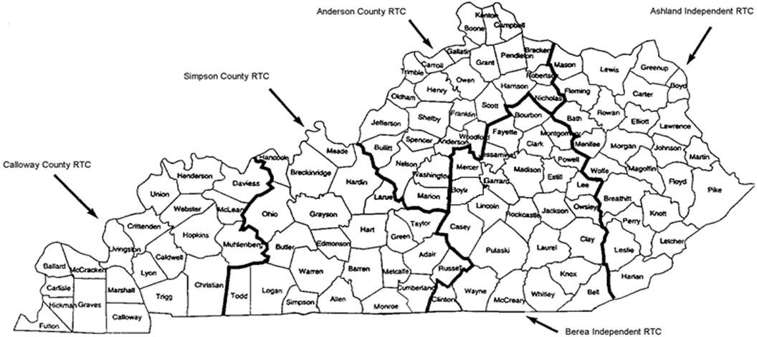
Kentucky Early Childhood Regional Training Centers

Anderson County RTC  210 Saffell Street  Lawrenceburg, KY 40342  (502) 839-2513 Fax: (502) 839-2516  Anderson Co. Regional Training Center Home Page | Alysia Wedding, Director  Penny Nutter, Early Childhood Specialist  Angela Brown, LINKED P-12 PBIS Coach  Julie Goodpaster, Secretary
Ashland Independent RTC  1820 Hickman Street  Ashland, KY 41101  (606) 327-2706 Fax: (606) 327-2796  Ashland Regional Training Center Home Page | James Lester, Early Childhood Specialist  Stacey Stevens, Early Childhood Specialist  Kerri Thornburg, Early Childhood Specialist  Krisi Davis, Secretary
Berea Independent RTC  1010 Brandy Lane, Suite B  Richmond, KY 40403  (859) 353-5479  Berea Regional Training Center Home Page | Sonia Michael, Director, Early Childhood Specialist  Misty Head, Behavior Coach  Brittany Sams, Behavior Coach  Andrea Ummel, Secretary
Calloway County RTC  PO Box 1018  Murray, KY 42071  (270) 809-5316 or 5317 Fax: (270) 809-3084  Calloway Regional Training Center Home Page | Nancy Lovett, Director  Chuck Williams, Early Childhood Specialist  Lisa Roberts, LINKED P-12 PBIS Coach  Britney York, Observation Specialist/Secretary
Simpson County RTC 211 South Main, Suite 1B Franklin, KY 42134  (270) 586- 2008 Fax: (270) 586-2809  Simpson Co. Regional Training Center Home Page | April McNaughton, Director  Laura Miller, LINKED P-12 PBIS Coach  Melissa Franklin, Secretary

